**Name:** Shubham Golwal

**Roll No.:** 2020300015

**Batch:** B

**Course Code :** OECS4

**Experiment No.:** 6

**Name of the Experiment :** Windows & Screen controls – Design a navigator for a person new in tourist Village.

**Problem Statement:** Designing a navigation app to help tourists in a new village presents a challenge in providing an easy-to-use interface that allows users to quickly and accurately locate tourist attractions, restaurants, hotels, and other points of interest. The app should also provide real-time updates on traffic conditions, road closures, and alternative routes to help users navigate the village with ease. Additionally, the app must be designed to function without an internet connection, as many tourists may not have access to reliable internet service while traveling. The app should be designed with the user's needs in mind and offer a seamless experience that enhances the tourist's visit to the village.

**Implementation:**

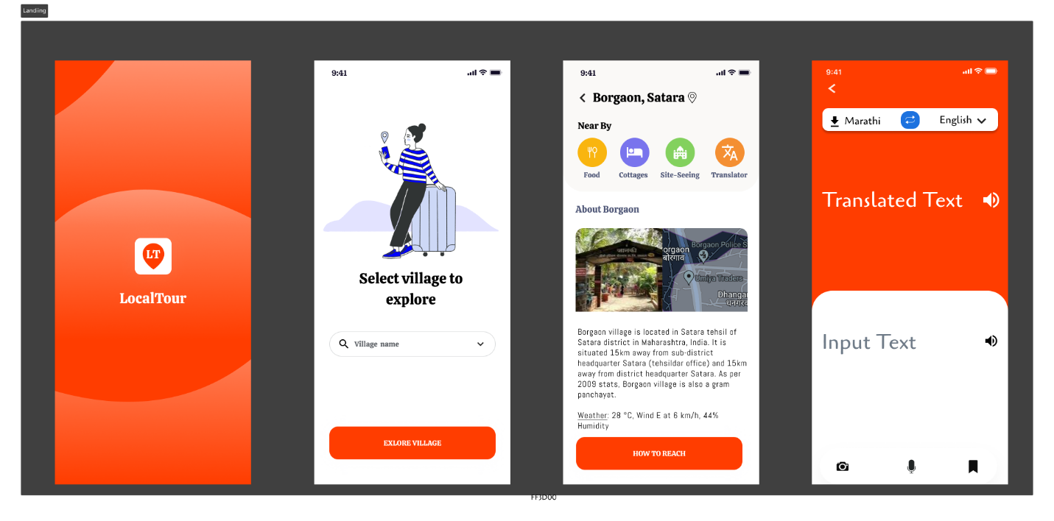

**Conclusion:**

In this Experiment, we built a navigator for a person new in tourist Village, in which we have applied Windows & Screen controls for better accessibility of different features of the website.

|  |  |  |  |  |  |
| --- | --- | --- | --- | --- | --- |
| Sr.No. | Principles | Poor | Average Good | Very  good | Excellent |
| 1 | Aesthetically pleasing |  |  | Yes |  |
| 2 | Compatibility |  |  | Yes |  |
| 3 | Comprehensibility |  | Yes |  |  |
| 4 | Consistency |  |  | Yes |  |
| 5 | Control |  |  | Yes |  |
| 6 | Efficiency |  | Yes |  |  |
| 7 | Flexibility |  |  | Yes |  |
| 8  9  10 | Forgiveness  Recovery  Responsiveness |  | Yes |  |  |